**Activated Sludge Process  
Suspended growth reactor**

In this type of reactor, reaction between organic matter and bacteria takes place in suspension on the surface of the suspended solids (suspended returned sludge particles).

The main objective of the activated sludge process is to stabilize organic matter and make it settleable.

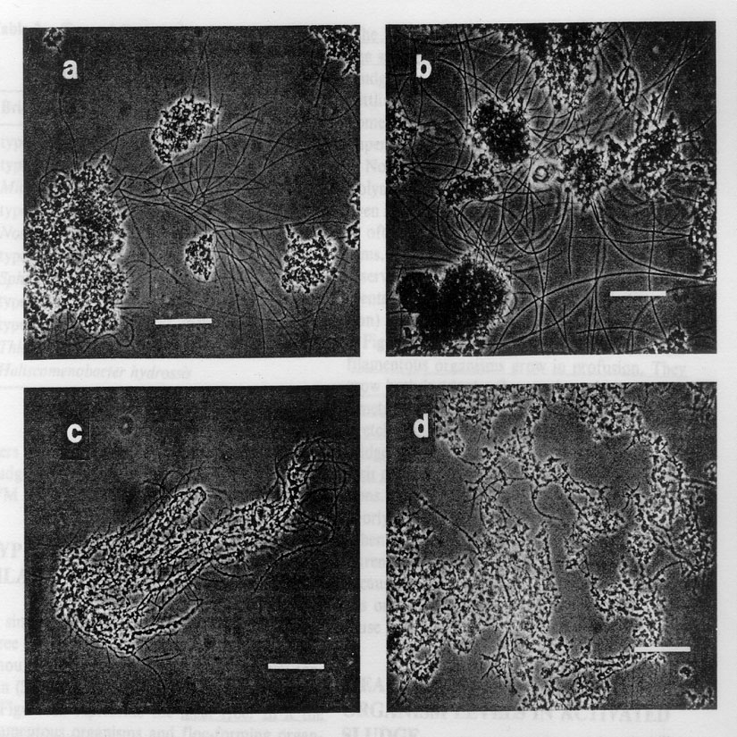

A microscopic photo of the reaction between organic matter and bacteria

which takes place in suspension solids on the surface of the suspended

**Types of activated sludge process:**

1- Conventional aeration.

2- Contact stabilization.

3- Step aeration.

4- Extended aeration.

5- Oxidation ditch (orbital aeration).

**Conventional aeration**

**Advantages of aeration tanks :**

1- It does not need large land areas.

2- It is more efficient than trickling filters.

3- No fly and odor problems occurs around the trickling filter.

**Disadvantages of aeration tanks:**

1- It can not take shock loads and sudden increase in discharge.

2- Needs a supervisor since it is the most complicated systems.

3- High cost of constructions, operation and maintenance.

P.S.T

A.T

X

Q

Q+QR.S

QR.S , Xr

Excess sludge

Qw

Xr

Effluent

Se

Xe

Set

Q - Qw

pump

Q

So

Xo

Flow line diagram of activated sludge process

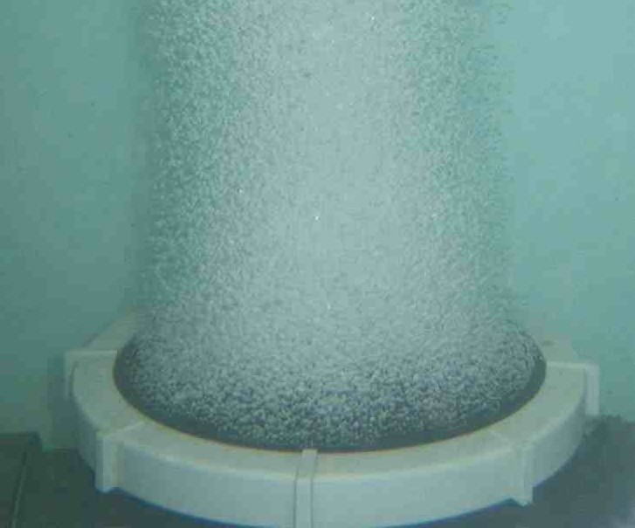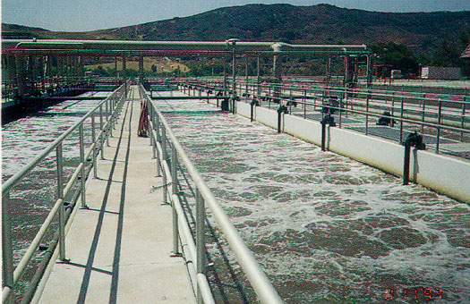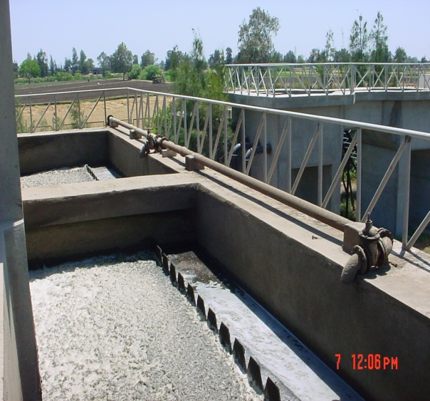

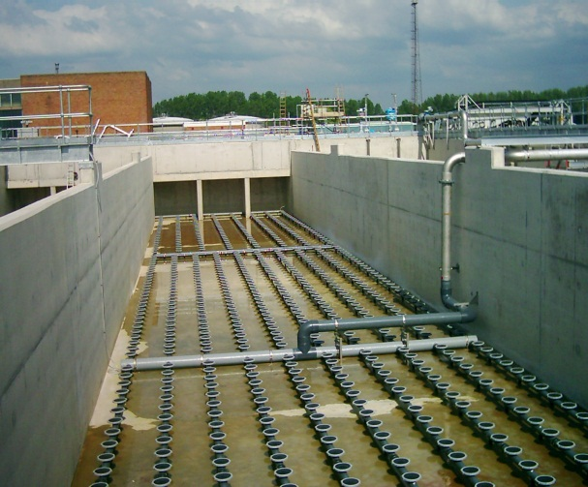

Diffused air system of aeration tank

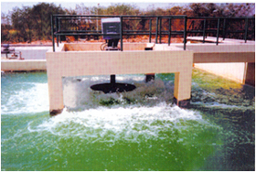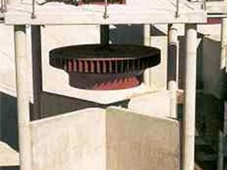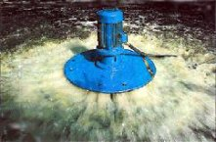

Surface aerators of aeration tank

Picture1

Aeration tank

Factors affecting design of aeration tank:

1- Temperature: the biological reaction increase with the increase of temperature.

2- Mixed Liquor is a mixture of raw or settled wastewater and activated sludge within an aeration tank in the activated sludge process.

Mixed Liquor Suspended Solids (MLSS) is the concentration of suspended solids in the mixed liquor, usually expressed in milligrams per litre (mg/l)

MLSS: (mixed liqueur suspended solids) 2000 - 4000 mg/L

MLVSS: (mixed liqueur volatile suspended solids)

MLVSS = 0.8 MLSS

If MLSS content is too high

* The process is prone to bulking and the treatment system becomes overloaded
* This can cause the dissolved oxygen content to drop with the effect that organic matters are not fully degraded and biological 'die off‘
* Excessive aeration required which wastes electricity

If MLSS content is too low

* The process is not operating efficiently and is wasting energy
* Typical Control band 2,000 to 4,000 mg/l

3- Hydraulic retention time = T = 4 - 8 hrs

4- Sludge return rate (R) = 0.2 – 0.3

R = QR / Qd

Return sludge QR.s = 0.2 - 0.3 Qd

5- Өc = SRT= sludge age (average time biomass stays in the system.

Calculated by total solids in system / total solids being wasted =5 - 15 days

Within the limits, a longer SRT results in:

* More efficient biodegradation
* Smaller reactor size
* Lower cost

If SRT drops below the cell regeneration time, biomass will wash out faster than it forms new cells.

**Types of aeration :**

1- Diffused air system

2- Surface aerators

**Design criteria :**



Q = discharge influent to the aeration tank (A.T).

= 1.5 x Qave sewage (Q = 0.8 x 1.5 x pop x qave )

So = dissolved BOD5 influent to the A.T.

Se = dissolved effluent BOD5

Xe = suspended solids concentration (S.S)

BOD5 suspended = S.S x 0.7

BOD5 dissolved = total BOD5 - BOD5 suspended

Se = Set – Xe x 0.7

X: total number of microorganisms responsible for the stabilization of organic matter.

X = MLVSS

MLVSS = 0.8 MLSS

Өc = sludge age =5 - 15 days

y: cell yield coefficient

y = gm MLVSS/gm BOD5

Y observed = y / ( 1+ kd Өc ) = 0.31

Kd = decay coefficient = 0.05 day-1

A = V / d

Depth = 3 - 5 m

n ≥ 2

b = 1.5 – 2 d

L ≤ 50 m

**Checks :**



Allowable organic load (L) = 0.3 - 2 kg BOD5 /m³/ day



Qw = sludge withdrawal rate

Xr =MLVSS in return sludge

Xe = effluent S.S

**Example:**

Determine the volume and dimensions of aeration tank and the required air flow for an activated sludge process treatment plant. Which is designed to treat the flow Q = 12000 m3/d and fined overall efficiency, F/M ratio, allowable organic load and the diffused air system. Given the following data:

- BOD5 of primary effluent (So) = 200 mg/l

- Required effluent BOD5 = 30 mg/l (Set)

- Required effluent suspended solids (Xe) = 20 mg/l

- MLVSS in aeration tank (X) = 2500 mg/l

- MLSS in return sludge = 10000 mg/l

- Cell residence time (θc) = 6 days

- Coefficient of decay (kd) = 0.06 day-1

- Cell yield coefficient (y) = 0.65 gm MLVSS/gm BOD5

- Efficiency of aeration = 8%

Q=12000

P.S.T

A.T

X=2500

Q+QR.S

QR.S , Xr

Excess sludge

Qw

Xr

Effluent

Se

Xe=20mg/l

Set= 30mg/l

Q

pump

Q

So=200mg/l

Xo

**Solution:**



Set

Dissolved suspended

Xe

70% organic 30% inorganic

BOD5 dissolved = BOD5 eff. – S.Seff x 0.7

Se =Set – Xe x 0.7

= 30 -20 x 0.7 = 16 mg/l



Assume d = 4m d= 3 – 5 m



Number of tanks n =2



Area of one tank =

b = 1.5 – 2 d take b = 8m



**Checks :**

Allowable organic load (L) = 0.3 - 2 kg BOD5 /m³/ day



T = 4 - 8 hrs



F/M = 0.2 - 0.4



Allowable organic load (L) = 0.3 - 2 kg BOD5 /m³/ day

**The design of the return sludge pipe:**



MLVSS = 0.8 MLSS

**Determination of excess sludge:**



**Design of diffused air system:**

**Design of air pipe in aeration tank:**



**Design of surface aerators:**

